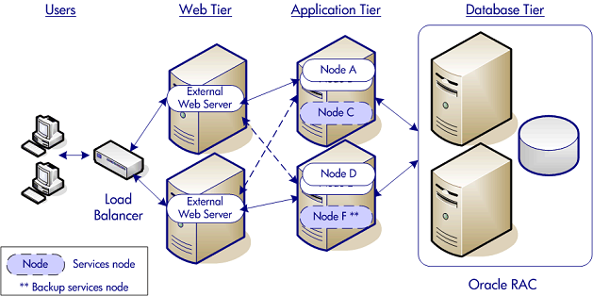

**Web Tier (BL860c x 2)**

* Microsoft IIS 6.0
* Microsoft IIS 7.0

**Application Tier (BL860c x 2)**

* HP PPM (OS HP-UX 11.31)

**Database Tier (RX6600 x 2)**

* Oracle 10.2.0.4 RAC
* Oracle 11.1.0.6 RAC
* Oracle 11.1.0.7 RAC
* Oracle 11.2.0.1.0 RAC